Lab 4 Activities

Akshit – 230784
Activity 1: This website implements a short test of working memory:
https://miku.github.io/activememory/
What was your score? Run the test 3 times and share your average score.

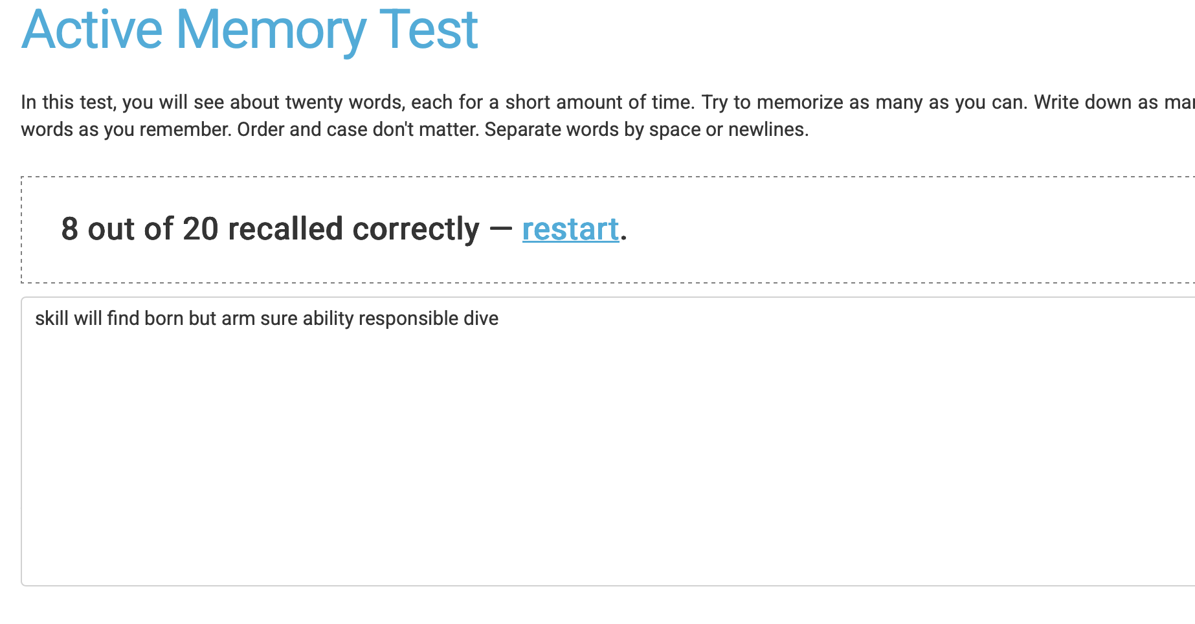

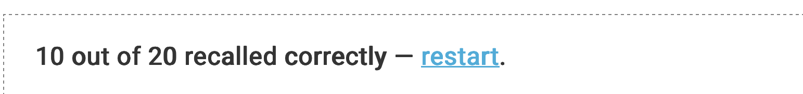

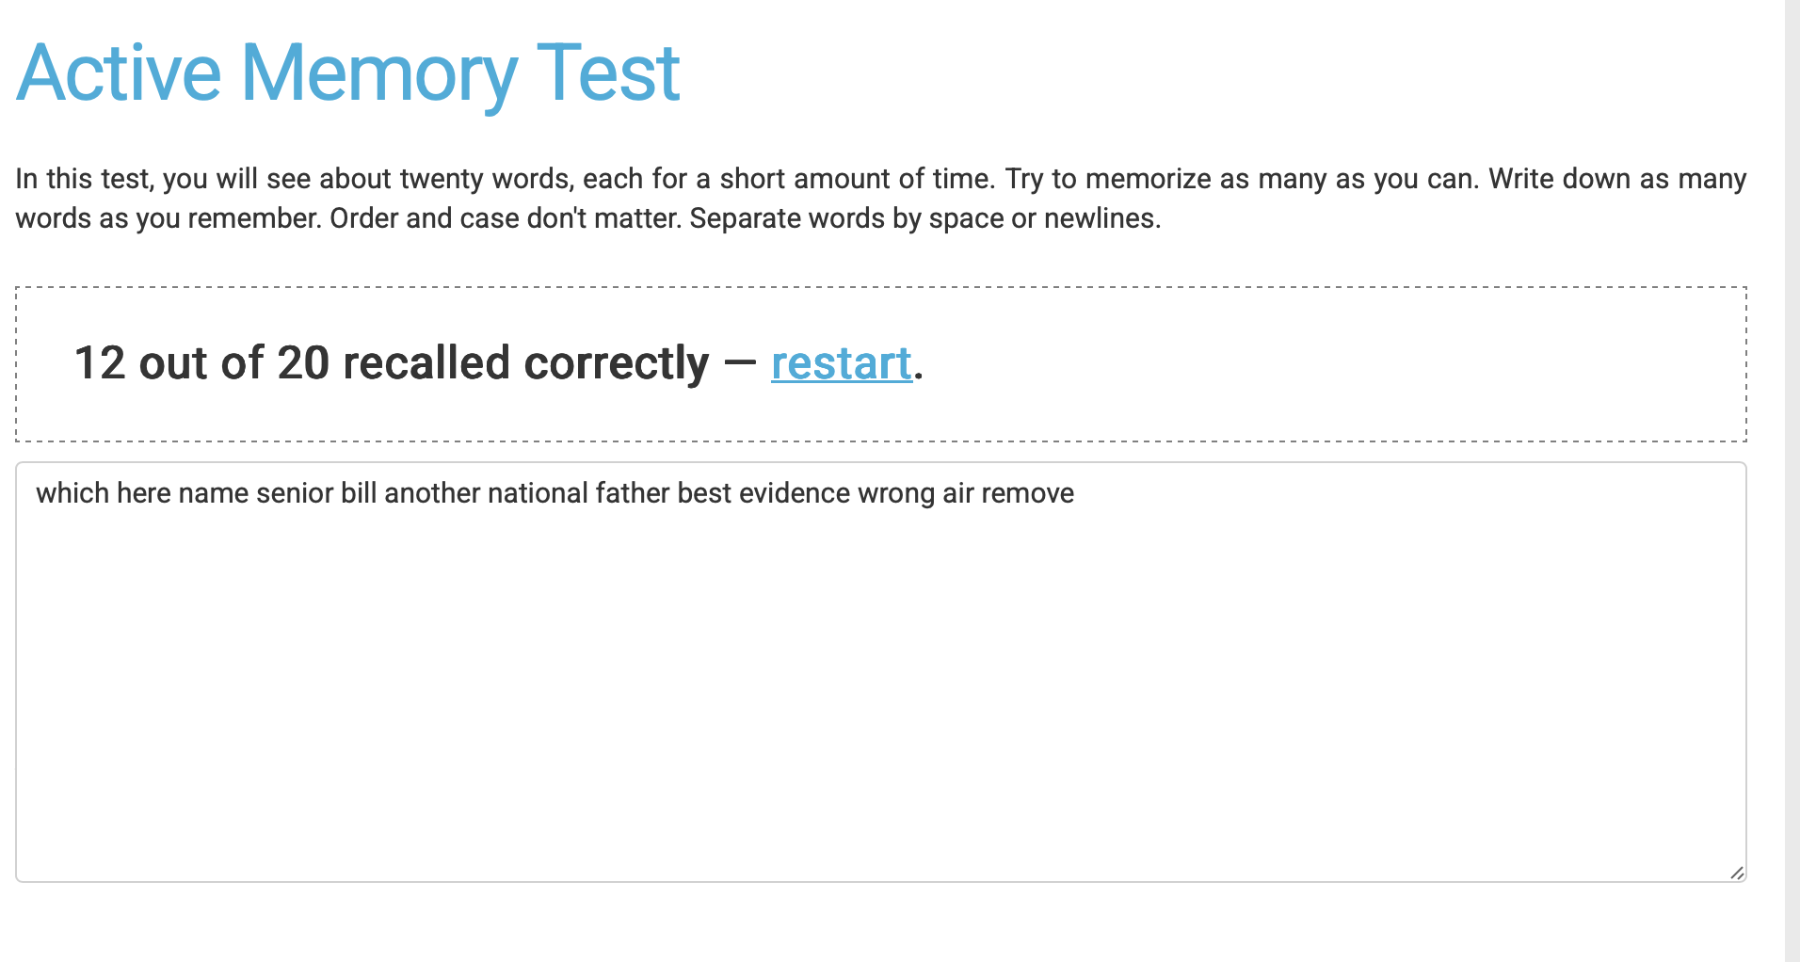

These are the 3 scores which came when I gave the test , the average score of these will be
8 + 10 + 12 = 30/3 = 10
So my average score came out to be 10.

Activity 2: What are some techniques (analog and/or digital) you use to concentrate on a task like studying and prevent your focus from wandering? Kindly write in your own words. Any generated or copied content will be penalized.
-------To make focus on a task like studying , I usually first make a rough read about that topic so as to kick in the motivation as well as know what am I going to actually read about . This makes me excited about it which increases the concentration first on. Then when I am doing that task , if I am watching a video or reading from a book , I keep a notebook handy to take notes and repeat the lines which are important by writing them down. This not only helps in remembering the topic , but also later revising those important points In case I am preparing for a quiz . To not lose focus from wandering , I use noise cancelling handphones to not to be disturbed from the surroundings as well as use the pomodoro timer. This timer works in short intervals and can be used as a extension in MacBook. Motivation to sit for longer hours and be productive is developed from this timer only.

Activity 3: Choose a website that you used and give around 10 examples (with screenshots) of where they are either following or breaking the principles of:
1. Attention (proper context, visual clutter)
2. Perception (understandable icons, proper borders, spacing and alignment, information grouping color contrast)
3. Memory (context, cognitive or memory overload i.e. over-complexity)
Note: Please don’t choose a very common website.

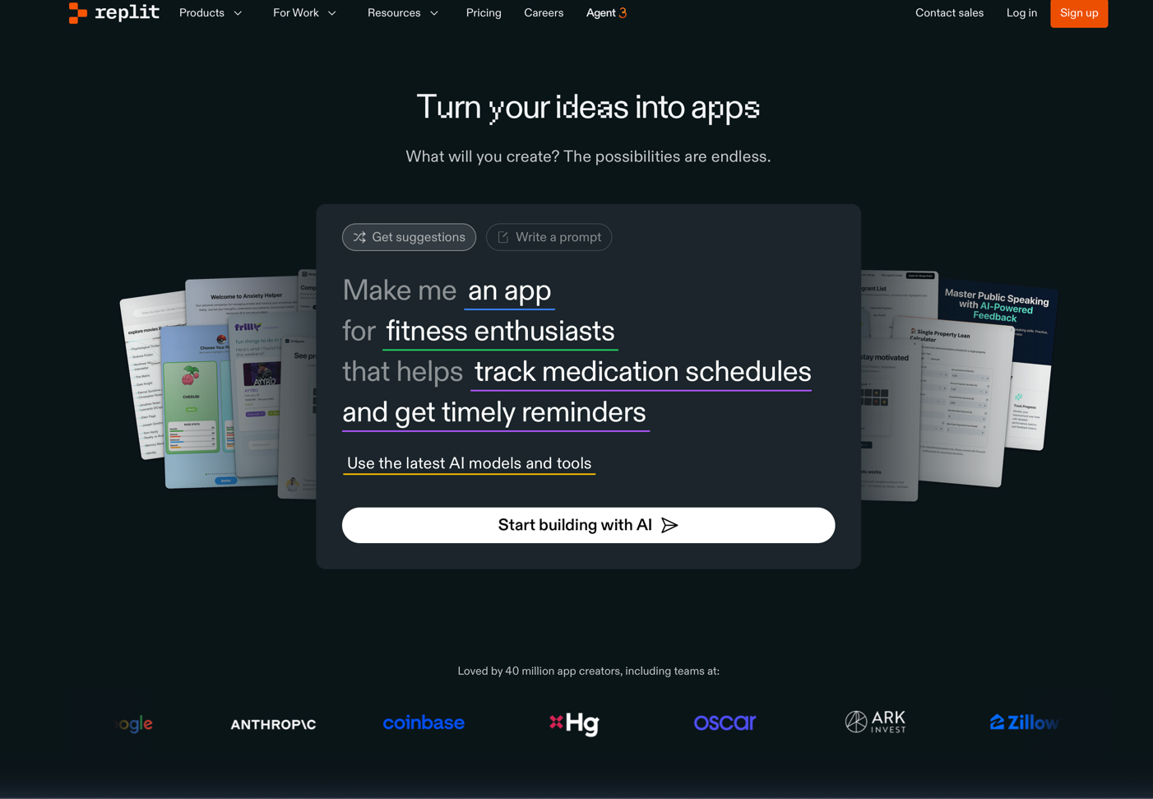
This is replit which is a website which uses generative as well as agentic ai to build app/websites. This website doesn’t look very user friendly as instead of telling what work its does or telling the prompts , its dashboard page looks very clustered as well as more like a sales company landing page
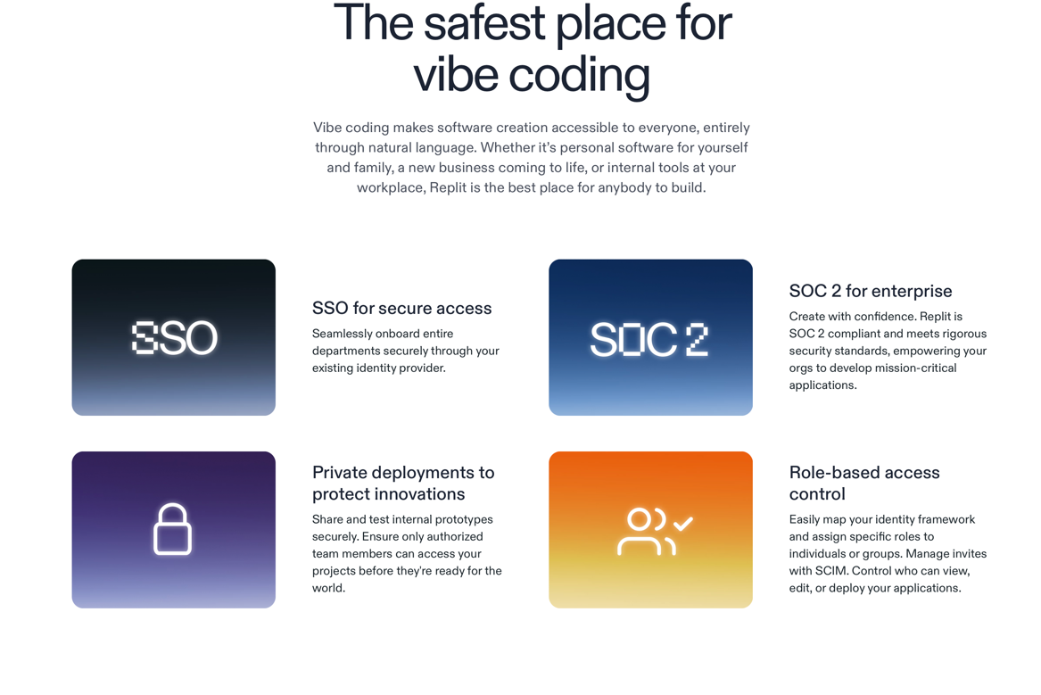

Here there is visual clutter as user is being thrown bunch of information instead of tutorials on how to vibe code as well as work using agentic ai.

When we login in the website , we are opened to this page with credits listed on the left side , this can be a little complex as the person can confuse this with a search bar instead of a agentic ai.

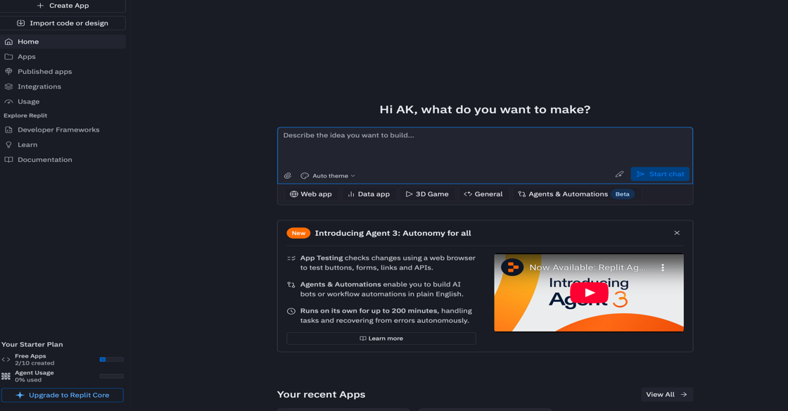
Here we can also see that the option to use a custom ai agent is not present and its selected random.

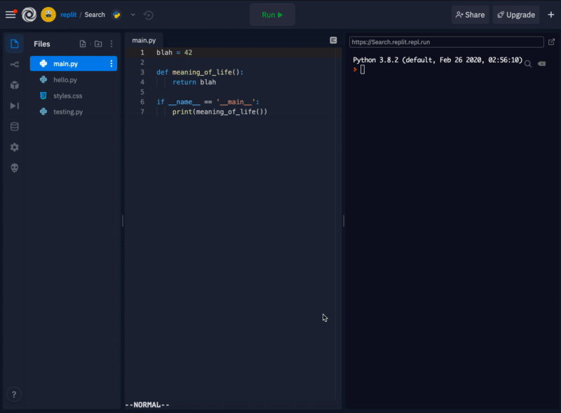

This is the split section of the replit which is a flexible pane layout lets users group information, arrange views to their workflows and have a good alignment of spacing between them.

But , it can be complex: dragging/splitting many panes can lead to a confusing layout; remembering how to rearrange panes or what each pane shows may overload memory. The visual cues for “where drop zones are” may be subtle, causing mis-drops.
Here in the side panel we can have option to intergrade GitHub as well as your past projects which you made.
When you make some changes in your project , to push the changes , you need to go into a side panel and then find the GitHub option over there to commit the changes. This is breaking of the perception principle as if there some changes to be committed , there has to be a simpler way to do so.

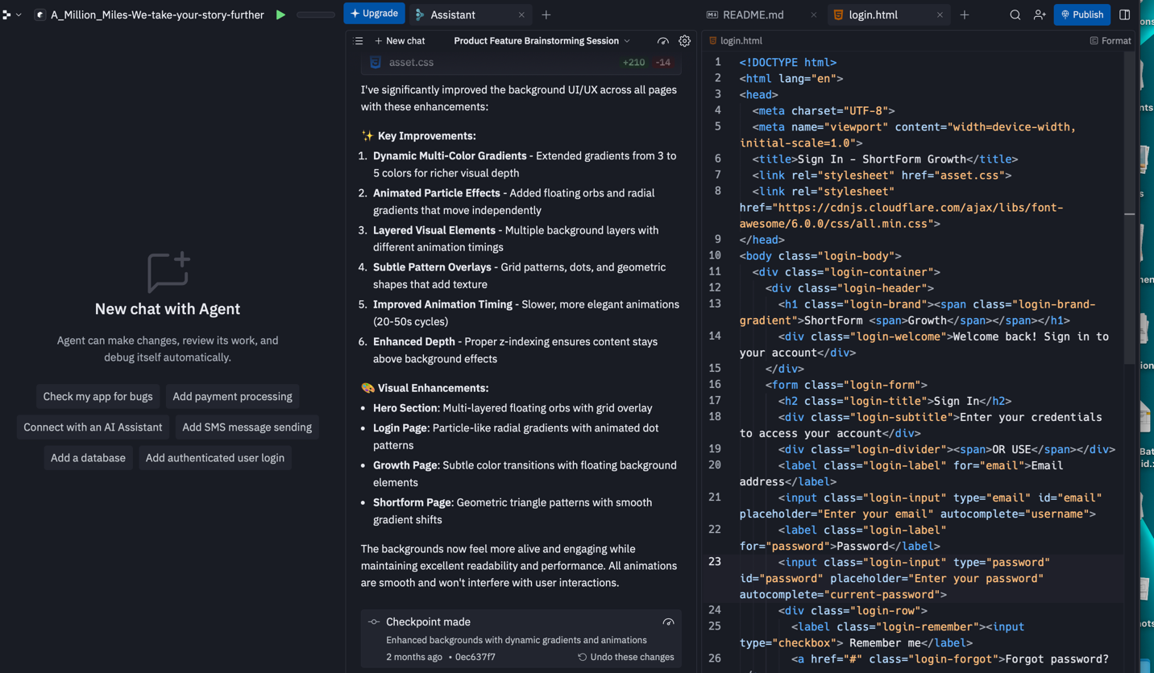
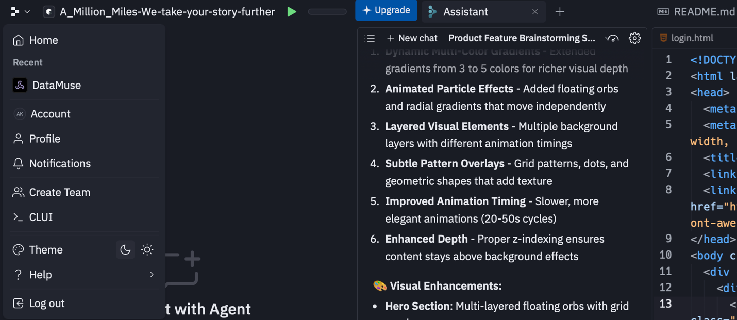

There is also a lack of terminal in the given website which makes it difficult for the people who use cli commands as well as terminal to use git or do other tasks.
Version history gives users the ability to see old states, compare side-by-side and helps with remembering what’s changed or recovering past work. This is present on the tools and files domain of the website.

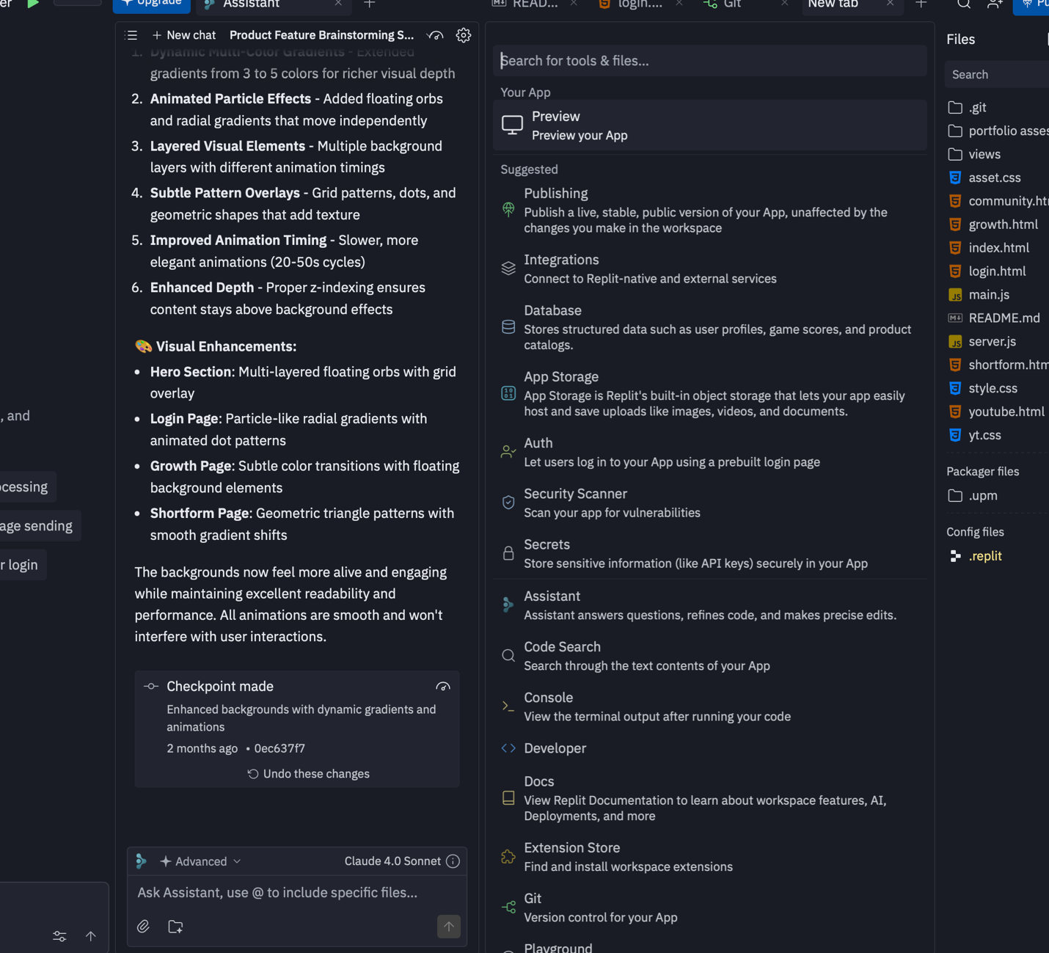

In the above , in the tools and files , lots of options in the tools panels can overwhelm new users as there are too many options without any hierarchy. The spacing in this panel is also very tight leading to some features not being understandable.

Activity 4: What are some efficient and secure ways of remembering and managing Passwords? Which ones do you use and prefer the most? Kindly write in your own words. Any generated or copied content will be penalized.
Being a IOS user , the MacBook has a method to save all your passkeys , as well as any login information you use in a website , app. It has the automatic ability to sense when you are entering sensitive information ranging from your address to phone number or the password you enter in a specific website. Since IOS has cross device functionality , the passwords from your phone are automatically stored In your device as well as in your iCloud.
Also I keep a backup of all the passwords written in a pages file in I cloud which is stored offline as well as password protected across all my devices.
This is in case I lose access the access to my laptop and need to enter some sensitive information.

